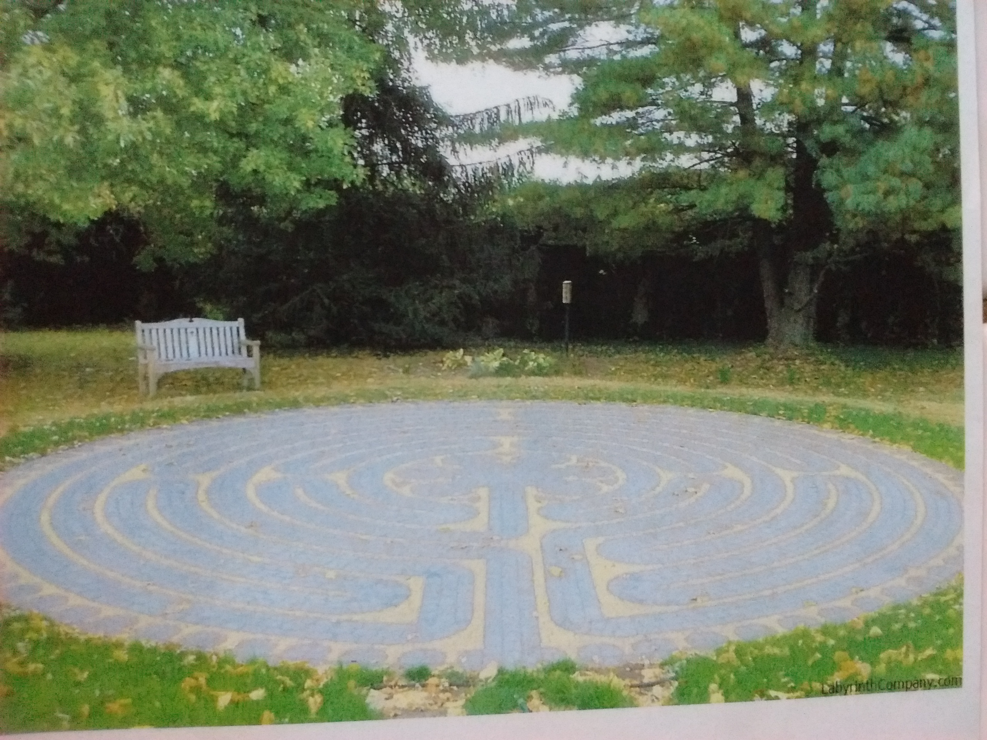
EAST SIDE NEIGHBOR and
Carlisle Area Sertoma
&
BRICK FUNDRAISER
for LABYRINTH and
TIME CAPSULE
In
BIDDLE MISSION PARK
CARLISLE
Your engraved brick will be placed in sidewalk leading to the entrance of the Labyrinth. The Carlisle Labyrinth will be built from the generous donations by the people and businesses from the surrounding areas. The Labyrinth will be unique because it is designed after the floor inside the Chartres Cathedral that was built about the year 1220. The Sertoma Club and ESNA are proud sponsors of this project and your generous donations are greatly appreciated.

1brk.- 4"x8" = $100.00 3 lines of engraving up to 17 characters per line, spaces, numbers and letters.

Purchased by:
Name:____________________________________________

Address:____________________________________________
City:__________________ State: _________ Zip: ___________
Telephone No:________________ Email:___________________

Engraving: PLEASE PRINT LEGIBLY/ ALL ENGRAVING SUBJECT TO COMMITTEE APPROVAL
LINE 1
LINE 2
LINE 3

Brick placement in sidewalk randomly placed. Bricks are available on a first-come, first-served basis, and there is no guarantee of actual location placement in the sidewalk. Contributions are tax deductible. The Biddle Mission Labyrinth Project Board is a (501c3) nonprofit operating under the Carlisle Area Religious Council (CARC), tax exempt number 23-2158651.

Please return completed form along with check payable to:
Biddle Mission Labyrinth Project Board
Any Question Please

Contact: ROGER SPITZ
spitzrc@aol.com
C/O Roger Spitz, Chairman
16 Thornhill Ct.
Carlisle, PA 17015

